The SAN JOSE POLICE RECRUITING UNIT will be hosting free monthly workshops for the CA POST PELLETB Written, WSTB Physical Agility, and Oral Interviews. This is a great opportunity for SJPD Police Recruit/Officer applicants to better prepare themselves for these phases of the testing process. Space is limited!

CA POST PELLETB Written Exam Workshop
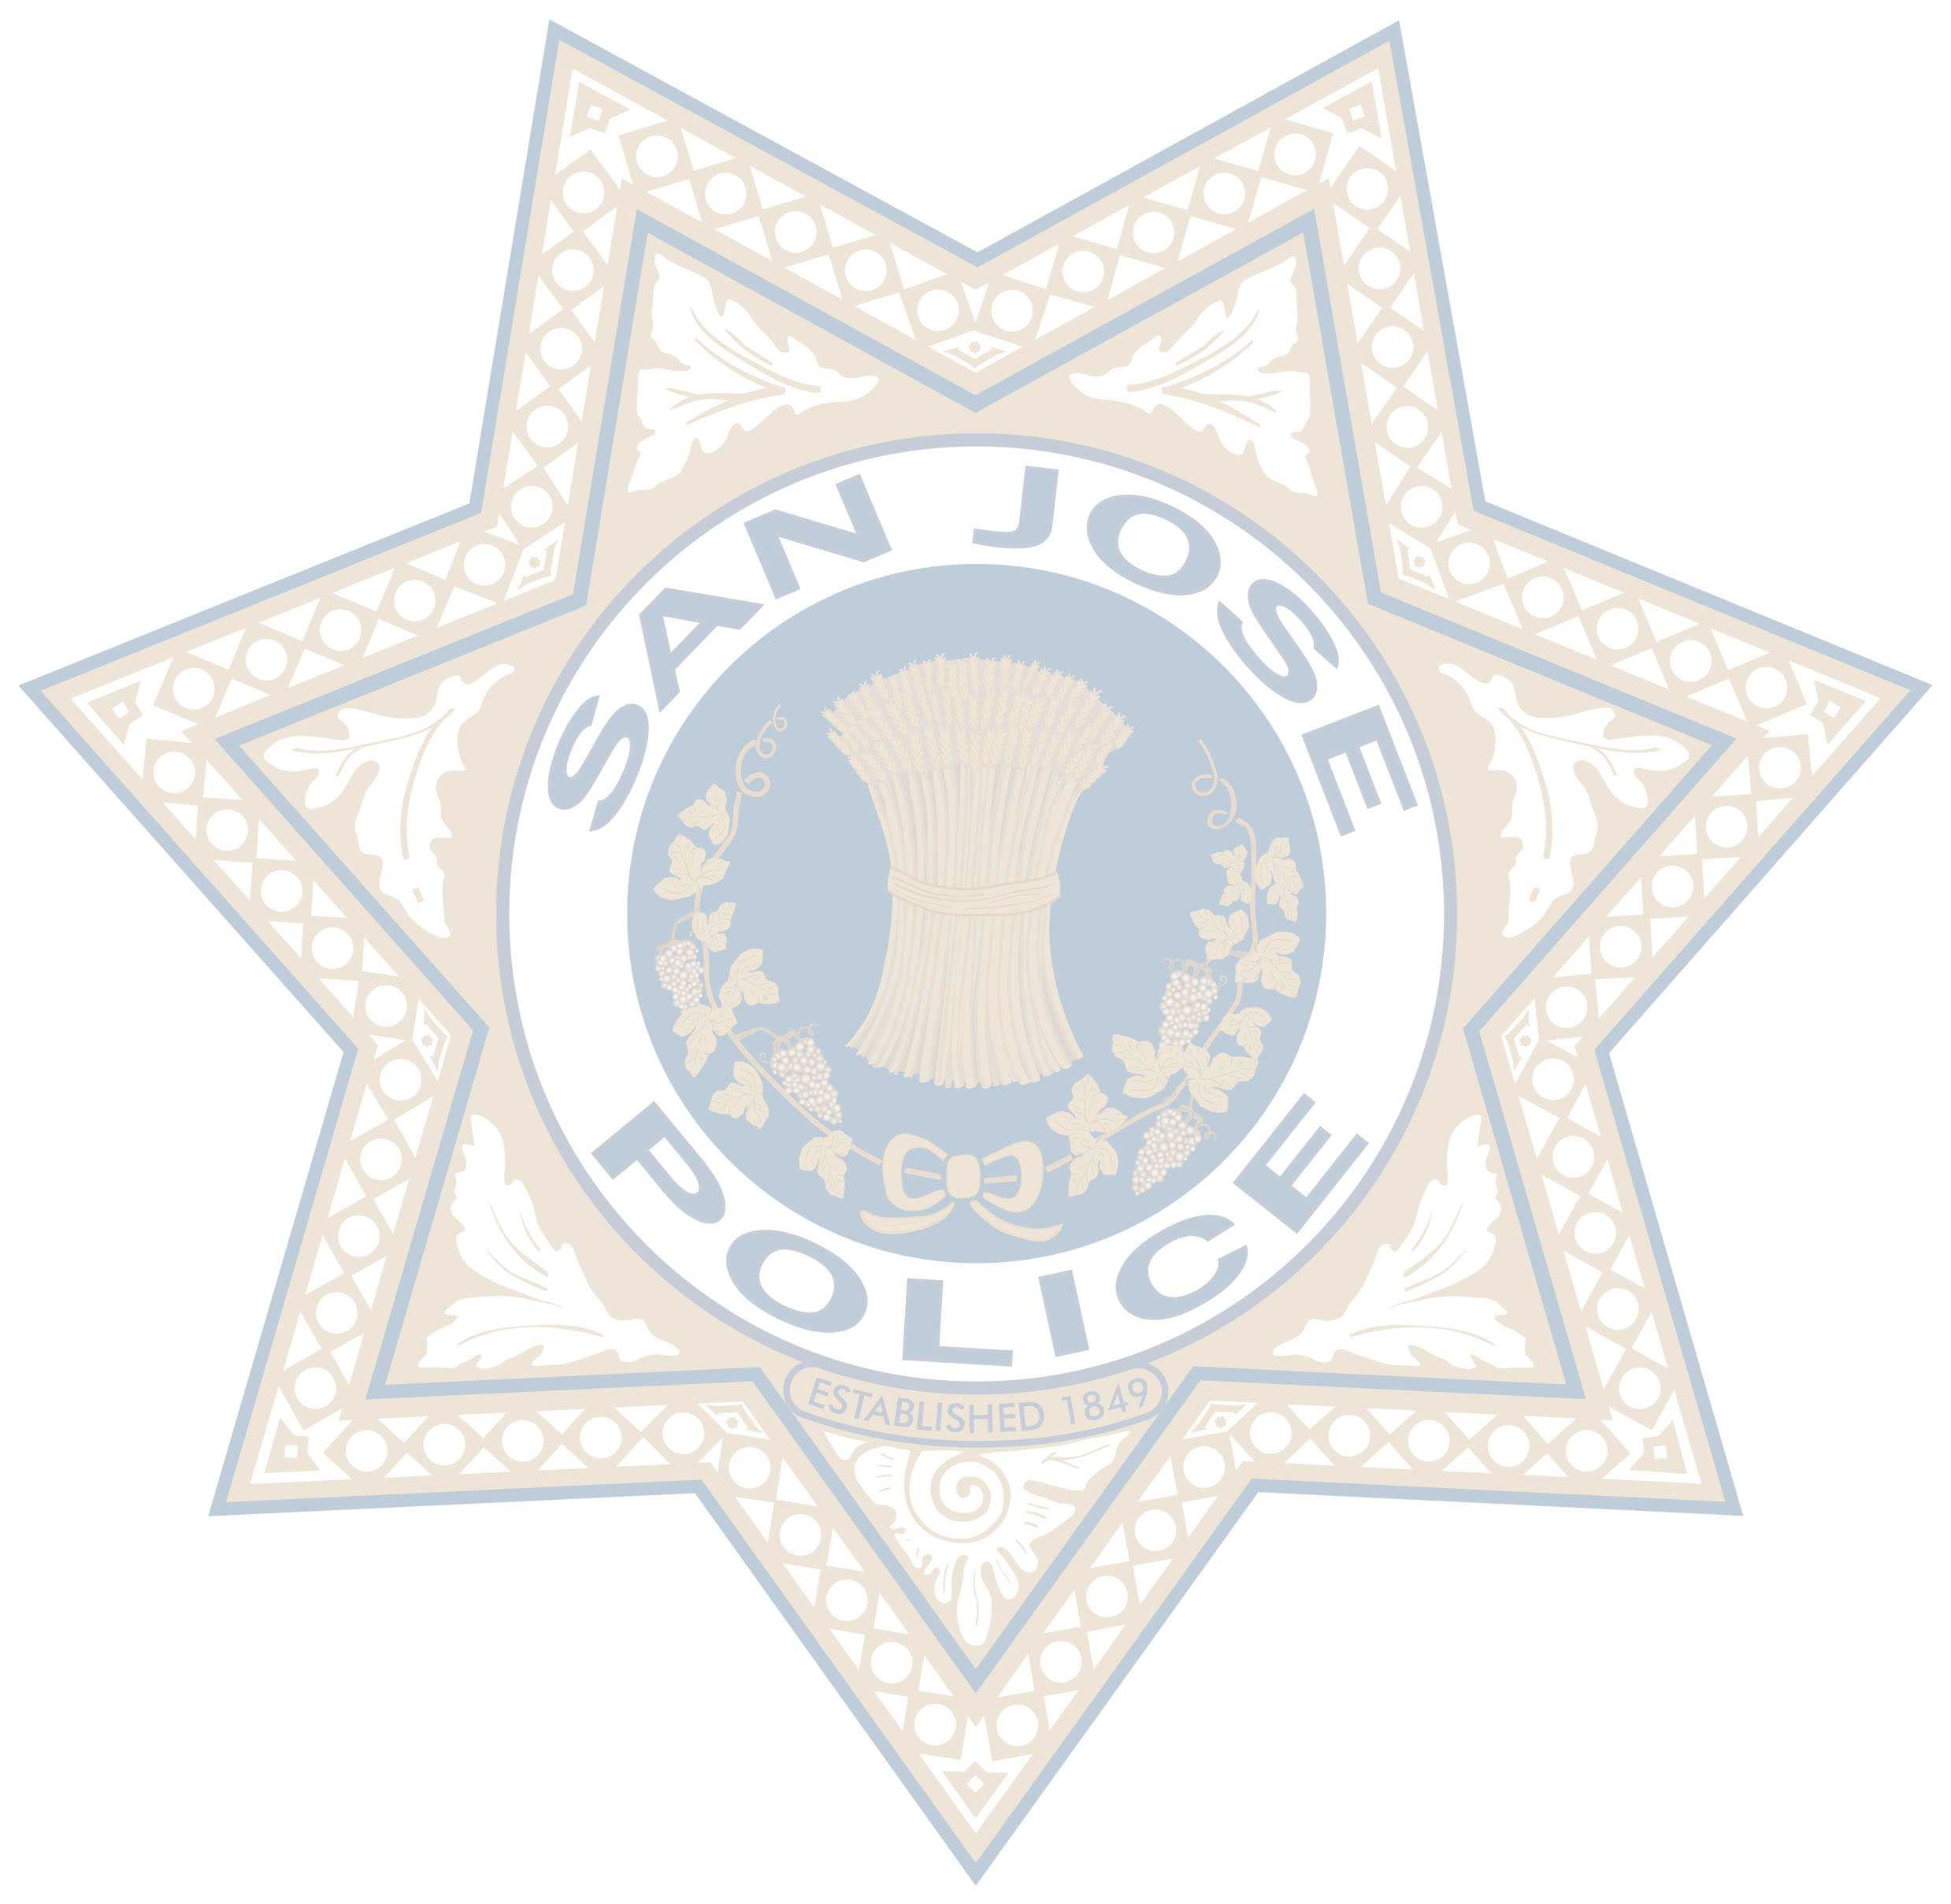
9:00 AM - 11:00 AM
For more information or if you have any questions, send an email to Stevie Daniels at:
thepostexam@gmail.com

REGISTRATIONS REQUIRED
Check-in time: 8:45 AM
Please visit https://capelletbworkshop2018.eventbrite.com to register

PRERECORDED SESSION:
https://zoom.us/recording/share/DEKoiUh qgLCUc5B1dHdnCWPP8fh6zHfOIPTCnyN46KwIumekTziMw

CA POST WSTB Physical Agility Practice Session
9:00 AM - 1:00 PM
Work Sample Test Battery (WSTB)
99 yard obstacle course, 165 lb. body drag 32 ft., 6 ft. chain link fence climb,
6 ft. solid wall climb, 500 yard sprint
1.5 Mile Run
While not included in the practice session, applicants will be required to complete a
1.5 mile run in 14 minutes or less.

REGISTRATIONS REQUIRED
Check in time: 8:45 AM
Please visit https://sjpracticewstb.eventbrite.com to register

Police Recruit/Officer Oral Board Workshop
5:00 PM - 7:00 PM
REGISTRATIONS REQUIRED
Check-in time: 4:45 PM
Please visit https://sjoralboardprepworkshops.eventbrite.com to register

For any additional questions:
Please visit www.SJPDYou.com
Contact the SJPD Recruiting Unit at 408-277-4951 or sjpdrecruiting@sanjoseca.gov

