**SAN JOSE POLICE DEPARTMENT**

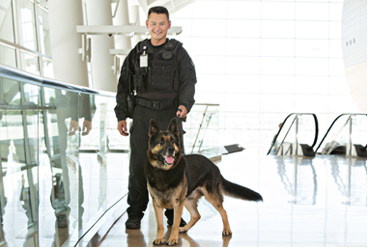

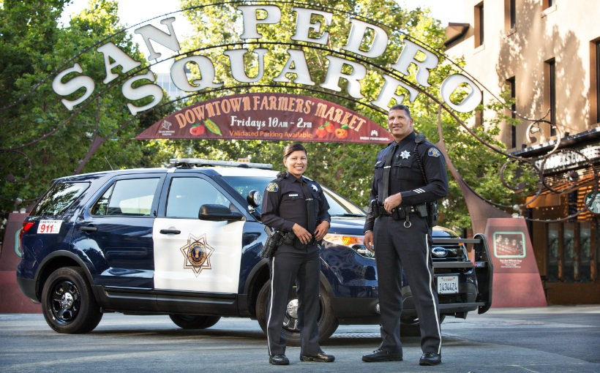

**Police Recruit**

**February 2020 Police Academy**

Your career starts here. The San Jose Police Department (SJPD) is hiring officers. If you are new to law enforcement, you will be hired as a Police Recruit and attend the San Jose Police Academy before becoming a SJPD Officer.

Apply online at [www.SJPDYou.com](http://www.SJPDYou.com)

***The San Jose Police Department is now accepting the National Testing Network (NTN) scores***

## **MINIMUM QUALIFICATIONS**:

* No experience or training required
* At least 20 ½ years-old at the time of application
* U.S. high school diploma or General Educational Development (GED); waived if you have a college degree from an accredited college within the U.S.
* Forty (40) semester college credits or 60 quarter college credits from a U.S. accredited college or university. Credits in-progress from another police academy are not accepted.
* **Military Veterans with an honorable discharge can substitute four (4) years of service in the U.S. Air Force, Army, Navy, Marines or Coast Guard in lieu of the minimum college credit requirement**
* Must be a U.S. citizen or a permanent resident alien who has applied for citizenship
* Possession of a valid U.S. driver’s license
* Must have at least 20/40 corrected vision
* No felony, domestic violence or misdemeanor assault convictions; cannot currently be on probation or parole

## **BENEFITS**:

* Paid Academy training for Police Recruit of **$39.29**/hour
* Annual base pay range for Police Officer with required POST training completed in the SJPD Academy: **$95,894 to $152,415\***
* Paid vacation and sick time accrual annually
* Annual uniform allowance of $675
* Four-day work-week, ten-hour shifts
* Bilingual pay – 2.5%

*Effective 7/20/2019  

**Police Recruit Application/Selection Process**

**ANNUAL BASE PAY RANGE FOR POLICE OFFICER: $95,894 to $152,415\***

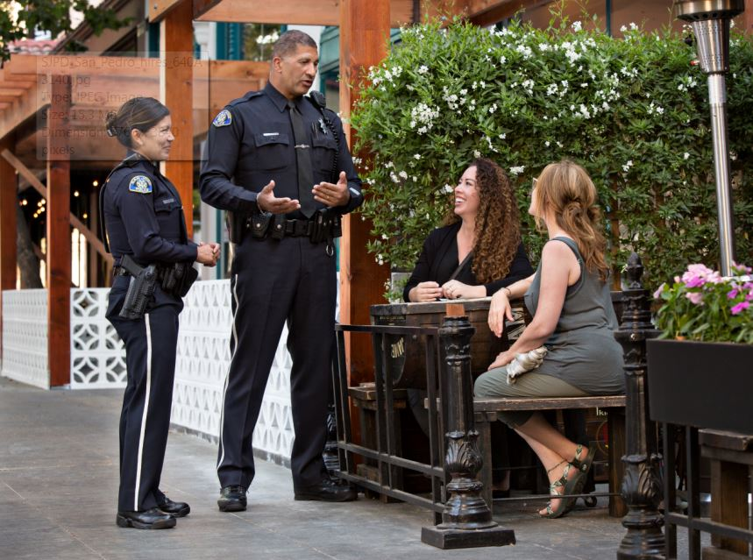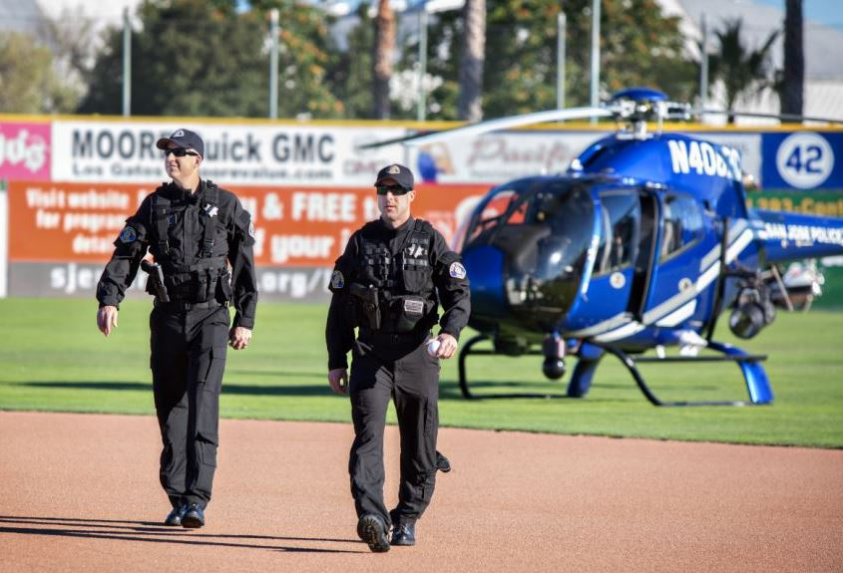

**SELECTION PROCESS**

**Step 1: Submit an Application:**

* Apply online at: [www.SJPDYou.com](http://www.SJPDYou.com)

**Step 2: Personal History Questionnaire (PHQ):**

* The Personal History Questionnaire consists of approximately 180 questions, which allow an applicant to self-report behavior(s) that have been determined to be related directly to job suitability. The PHQ is designed to identify applicants who do not meet the minimum standards to become a Police Recruit; saving the ineligible applicant considerable time and effort involved in the testing process. PHQ results are valid for one year.

**Step 3: Written and Physical Agility Exams:**

* Candidates must pass **ONE** of the below written examinations:
  + **PELLETB**: Complete the **California P.O.S.T. Reading & Writing Test (PELLETB).** Pass Point is a T-Score total of 50 or higher. (Results valid for three years.) For more information or to register go to: <http://www.theacademy.ca.gov/tests>
  + **National Testing Network (NTN):**: Complete the **National Testing Network Test (NTN)**. Pass Point scores are 65% Video, 70% Reading, and 70% Writing. (Results valid for three years). For more information or to register go to:

<https://www.nationaltestingnetwork.com/publicsafetyjobs/>

* Complete the **California P.O.S.T. Physical Agility Test (WSTB)**. Pass Point is a score of 320 or higher. Also included in the Physical Agility Test is a 1.5 mile run, which must be completed in 14 minutes or less. (Results valid for one year.)

**Step 4: Oral Board Interview:**

* This is a panel interview. Candidates will be asked five to eight questions, not necessarily police-related. Pass Point is 70% or higher. (Results are valid for three years). Candidates who successfully complete all portions of the testing process will be placed on a list of eligible candidates for the Background Investigation process.

**Step 5: Background Investigation:**

* Candidates will complete a pre-background assessment
* Eligible candidates will complete a Personal History Statement (PHS) packet. Background investigators will then be assigned to assist candidates through the process. Upon successful completion and review of the background investigation, the hiring board will make their employment selections. Those selected will receive a conditional offer of employment, contingent upon successfully passing a medical and psychological exam.

**Step 6: San Jose Police Academy**:**

* The Academy is a 26-week program; Police Recruits are considered a City of San Jose employee and will earn $39.29 an hour while attending the Academy. Upon graduation, eligible candidates will enter the Field Training Program (FTO) for additional training as a SJPD officer on the street. Those who successfully complete the FTO program are assigned to the Patrol Division as a solo beat officer.

*Effective 7/20/2019

**Not a “live-in” Academy