SBIA FRIDAY NIGHT LIGHTS

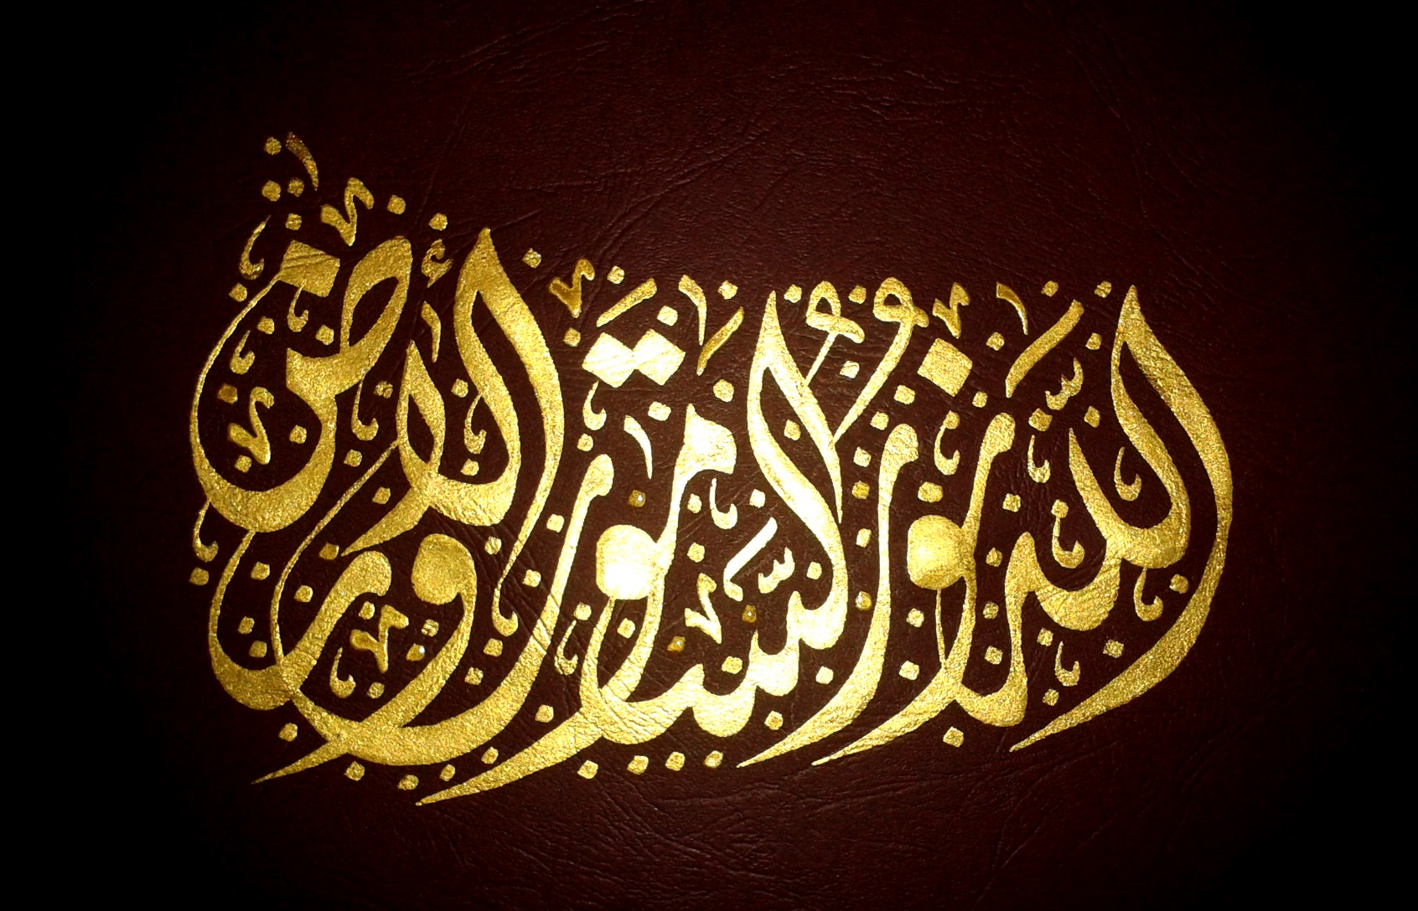

Allah is The Light of the Heavens & the Earth

(Surah Noor (24) v. 35 )

Allah points out in the Quran that “*people of understanding*” .. “*reflect on the creation of the heavens and the earth, [saying], 'Our Lord, You did not create this aimlessly****; ……..'"*[Quran 3:191]**

Also He tells us [it is He] “*Who created the seven heavens one above another; you see no incongruity in the creation of the Beneficent Allah; then look again, can you see any disorder ?”* ***"*[Quran 67:3-4]**

In Friday Night Lights we will explore Allah’s amazing creations in an atmosphere of lights, that will enlighten our world - with mind-blowing images and video presentations from the latest discoveries and pictures in space from NASA and space telescopes, to the amazing microscopic creations revealed through microscopes and electron microscopes, and into the depths of the colorful world in the deep oceans.

Weather and instruments permitting we can see the giant planet Jupiter as this night it will be at its closest approach to Earth and its face will be fully illuminated by the Sun. This is the best time to view and photograph Jupiter and its moons. A medium-sized telescope can show some of the details in Jupiter's cloud bands. A good pair of binoculars will allow you to see Jupiter's four largest moons, appearing as bright dots on either side of the planet.

We will provide a list of other celestial events in 2015 – it being one of the most eventful celestial years (65 events) including 6 supermoons (3 visible as full moons), 4 eclipses and lots of planetary paloozas that will keep you busy looking up at the sizzling skies throughout this year.