Come and see the proposed

**New SBIA Headquarters!**

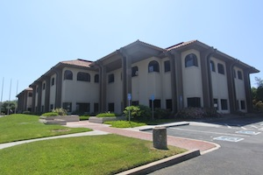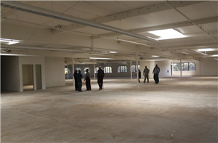

**Open House**

***Lunch Included***

**Saturday, August 24**

**Noon – 2:00 pm**

Program

12:00 - 12:15 pm: Welcome                 
12:15 - 12:45 pm: Site Tour

12:45 - 1:15 pm: Lunch  
1:15 – 1:25 pm: Remarks by Imam Tahir

1:25 - 1:45 pm: Project presentation  
1:45 - 2:00 pm: Zuhr prayer

**2345 Harris Way, San Jose**

**(Just off Hwy. 880 @ Montague Expwy)   
Be sure to RSVP so we can ensure we order sufficient food: sbia@sbia.info**