**Focusing On Our Future**

**A Fundraiser for the New SBIA Building**

*70,000 square feet * Ample parking * Plans for Women’s, Seniors’, and Youth Centers * Significant rental income potential *

Do not miss this evening to remember, featuring:

* **Shaykh Hamza Yusuf**
* **Shaykh Alaeddin El-Bakri**
* **Nasheed Artist Nader Khan**

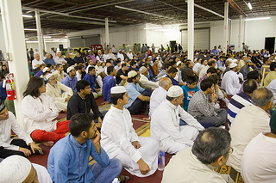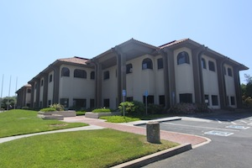

**Saturday, September 7**

***Your Parking Prepaid***

**6:00 pm**

***Free Professional Babysitting***

**DoubleTree Hotel**

**2050 Gateway Place, San Jose**

Tickets: $40/Person and $15/Child (Ages 8 and below – Babysitting Room with pizza dinner). For more info, contact:

Sr. Muneeza Danial: [enriq2002@hotmail.com](mailto:enriq2002@hotmail.com) 408.396.2730 Br. Shan Saigal: [swsaigal@hotmail.com](mailto:swsaigal@hotmail.com) 408.505.9302

Br. Arif Khan: [arif.khan@gmail.com](mailto:arif.khan@gmail.com) 408.667.7289 Br. Athar Siddiqee: [athars@gmail.com](mailto:athars@gmail.com) 408.802.4705

Br. Qamaruzzaman: [muqzaman@gmail.com](mailto:muqzaman@gmail.com) 408.839.4662 Sr. Rafia Syed: [rafiaemail@yahoo.com](mailto:rafiaemail@yahoo.com) 510.745.8672

Br. Adnan Rasheed: [adrash15@sbcglobal.net](mailto:adrash15@sbcglobal.net) 408.876.8901 Sr. Yasmin Vanya: [yasnohana@sbcglobal.net](mailto:yasnohana@sbcglobal.net) 408.250.6227

Br. Raheel Merchant rym2799@gmail.com 408.590-2855 Br. Suleyman Yesilyurt: [s.yesilyurt3@gmail.com](mailto:s.yesilyurt3@gmail.com) 408.806.5643