  
**South Bay Islamic Association**

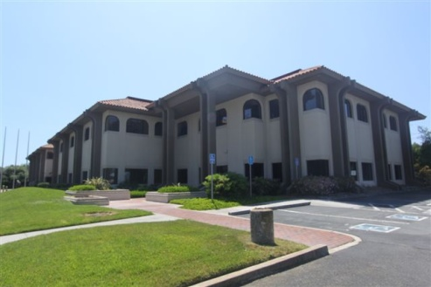 proudly presents 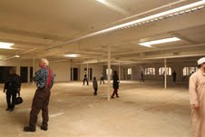  
**a very special**  
**Family Night**

**SBIA Special Projects Committee**

**Focusing on SBIA’s New Islamic Center Project  
Friday, May 10, @ 7:00 pm Sharp  
Note Location: 2345 Harris Way, San Jose**

Program  
7:00 - 8:00 - Dinner  
8:00 - 8:15 - Maghrib Prayer  
8:15 - 8:45 - Project Presentation   
8:45 - 9:00 - Talk by Hafiz Ilyas Anwar

9:00 - 9:30 - Talk by Sh. Alaeddin El-Bakri

9:30 - 9:45 - Isha Adhan/Prayer

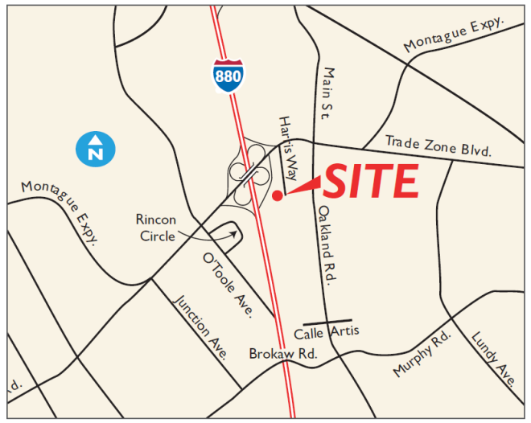

Dear Community Members,  
  
Assalam-u-alaikum. The SBIA Board of Directors and Board of Trustees have entered into a contract to purchase the property at 2345 Harris Way in San Jose. This property will, Insha-Allah, become the new headquarters of the organization.  
  
We look forward to the community’s active participation in this project, and pray that it becomes a beacon of guidance for generations to come, an oasis of spiritual nourishment that rejuvenates our souls, and a forum for the wider community to partake in activities for all.  
  
Please come to learn more about the property and help us make this dream a reality.   
  
Br. Mahbub Khan (408) 859-3566, Br. Shan Saigal (408) 505-9302, or Br. Adnan Rasheed (408) 876-8901